Hello Julián,

I hope this email finds you well. The following questions about your paper “Finite-State Markov Chains Channel Model for CubeSats Communication Uplink”:

* One of the first challenges we faced was deducing a formula for θ(t), the elevation angle of the satellite observed by a ground-terminal. We have reviewed reference [32] of your manuscript (Doppler Characterization for Leo Satellites), but there is no explicit formula for the required variable. Could you provide some guidance on how to deduce this equation?
* We have encountered problems while attempting to replicate figures 5 and 6 (BER curves for B-sector and G-sector) of the paper, particularly when calculating the crossover error probabilities for the G-sector. Our MATLAB implementation shows divergence when using equation 13 (see picture below), particularly for higher values of m, and negative SNRs. This causes the BER curves to cross over each other, as well as exhibit unexpected behavior.

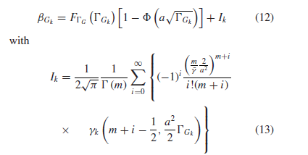

The following image shows the graphs we have produced for the G-sector BER curves. You can see that for SNR values above 0 [dB] the curves tend to agree with what you have shown in your work. However, for low SNRs, the results appear to be wrong. Could you perhaps share details of the MATLAB implementation for the G-sector, particularly for the Ik terms related to the infinite series estimation.

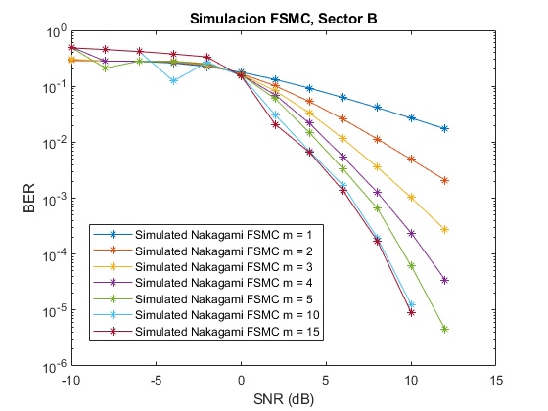

* Our last inquiry concerns the validity of this model in the scenario we are interested in, which considers LoRa for the physical layer. As the bit transmission rates tend to be substantially lower than what you consider in the manuscript (105 [bps]), we believe that the slow-fading assumption might not be valid in our scenario. Thus, the FSMC model, with the transition probabilities calculated as you have proposed, might no be applicable for our studies. Do you agree on this regard?